**Preamble:**

You are about to be thrust into the role of a materials manager. Your job will be easier than most material managers because you only have three items to manage. But, your role will be harder than most material managers, because time is greatly compressed and you must make split second decisions about when to order more stock.

Before you begin, read the following to become familiar with the screen layout.

For each of the three items you will see a strip across the screen that looks like this:

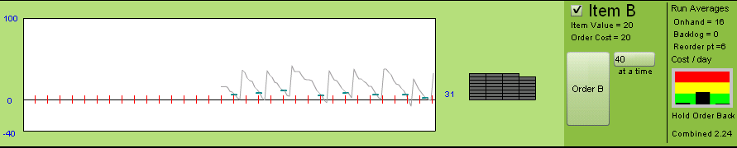

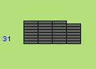

The number of boxes of the item on-hand is shown as a stack, in gray. To the left is written the quantity, in this case, 31. As the simulation runs, you will see the number of boxes decrease. If you should happen to run out of merchandise, you will see boxes in red, dropping below the zero line, representing back orders.

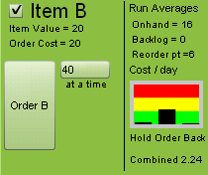To the right of the boxes is the control panel. Besides listing some information about the item, such as its name, cost per item and the cost to place an order for this item, you will see a large button and a drop down menu off to the right. To place an order for the item, you click the button. The amount ordered will be whatever quantity is displayed in the drop down menu at the time the order is placed. You can change the order quantity by selecting a different value in the drop down menu. (By the way, you cannot place an order for a product if one is already pending for that product. A click on the button when an order is pending will be ignored.) Next to each item name is a checkbox that allows you to enable or disable the item as you make experimental runs.

On the right half of the control panel are some performance statistics. You can see the average amount on-hand, the average amount backordered and the average quantity at which you placed an order. There is also a gauge that shows how you are doing on costs. If a bar is in the red region, your costs are dangerously high. If yellow, you still need to improve, if green, you are performing well.

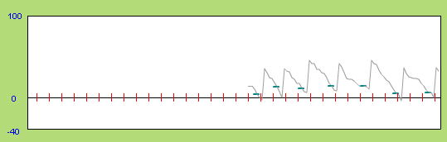

To the left of the boxes is a graph of on-hand inventory as a function of time. The tick marks on the graph (in red) occur every 5 days. There is a small horizontal line (green for item B) that shows the inventory level when an order was placed.

Across the bottom of the screen you will see a clock that shows you how many of your 365 days have occurred so far. To the right of the clock, are the control buttons for the simulation, Run (or Pause, when the simulation is running) and Reset, and the grand total cost/day for all three products.

Several of the buttons have keyboard equivalents. You can press A, B, or C to order items, and the space bar alternately continues and pauses the simulation.

**Technical Issues**

The inventory simulation can be found at:

<http://www.cbpa.drake.edu/bmeyer/POOL/OrderSim/>

The simulation runs in a web browser and uses Flash. You probably already have Flash player installed. If not, it can be downloaded free from <http://get.adobe.com/flashplayer/>.

You will need to see the entire simulation screen at one time. If your monitor is set at a lower resolution, you may not be able to see it all at one time. If this is the case, go into your computers settings and switch to a higher resolution. The simulation uses 900x600 pixels, and your browser heading and menus take up some space as well, so pick a resolution that would be somewhat larger than 900*600.

The simulation has been tested extensively with the Firefox browser and works well with that browser on both PCs and Macs. Other browsers seem to work fine as well.

**Assignment:** Run the simulation for the following three levels and write the answers to the questions below on the next page to hand in at the beginning of class.

**Level 1:** With only Product B turned on (make sure the boxes in front of Item A and Item C are not checked) experiment with the simulation and figure out how to minimize cost/day. Find an approach which results in cost per day less than 1.85. Feel free to reset the costs after you decide on changes in order to get the full effect of the changes.

a. What was the **best** **quantity** of B to order at a time?

b. For this best order quantity, describe how the costs compare on the cost bar gauge.

c. What was your rule for **when** to place an order for B?

d. How did you discover this?

**Level 2:** Now enable product C by clicking in the check box to Include C. Reset the simulation without resetting the order quantity for product B. Run the simulation with both products and figure out how to minimize cost. (Feel free to turn off B for awhile, if you think it would help you.) Find an approach which results in total cost per day less than 2.20.

a. What was the best quantity of C to order at a time?

b. What was your rule for when to place an order for C?

c. How is the demand for item C different than the demand for item B?

**Level 3:** Enable product A and minimize Total cost/day. See if you can attain a total cost per day of less than 11. (Remember, the space bar starts and stops the simulation and you can order by pushing the product name-A, B, or C- on the computer keyboard.)

a. What was the best quantity of A to order at a time?

b. What was your rule for when to place an order for A?

c. What was your best TOTAL cost /day? (for a duration of at least 200 days.)

d. What difficulties did you encounter trying to manage all three products at the same time?

e. What was your strategy to get this lowest cost? (Any rules of thumb you used.)

f. Compare the best order quantity for item A with that for item C. Which one is smaller? Why is it smaller than the other one?

**Answer sheet Name _________________**

**Level 1:**

a. What was the **best** **quantity** of B to order at a time? ____________

b. For this best order quantity, describe how the costs compare on the cost bar gauge.

c. What was your rule for **when** to place an order for B?

d. How did you discover this?

**Level 2:**

a. What was the best quantity of C to order at a time? ______________

b. What was your rule for when to place an order for C?

c. How is the demand for item C different than the demand for item B?

**Level 3:**

a. What was the best quantity of A to order at a time? _____________

b. What was your rule for when to place an order for A?

c. What was your best TOTAL cost /day? (for a duration of at least 200 days.) ________

d. What difficulties did you encounter trying to manage all three products at the same

time?

e. What was your strategy to get this lowest cost? (Any rules of thumb you used.)

f. Compare the best order quantity for item A with that for item C. Which one is smaller? Why is it smaller than the other one?